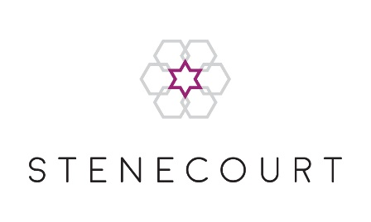

# Full Membership Application Form

I wish to apply for full membership of the Manchester Great, New and Central Synagogue (Stenecourt).

To become a Full Member of Stenecourt, you should also apply to join Stenecourt’s Burial Board or be a member of another Burial Board[1]*.

I am applying to join the Stenecourt Burial Board:

I am a member of the Burial Board of:

I give permission for the above-mentioned Burial Board to be contacted to confirm:

Full Name (including title):

Address:

Telephone Number:                                                    Mobile Number:

Email Address:

Date of Birth:                                                   Hebrew Date of Birth:

Hebrew Name:

Father’s Hebrew Name:

Mother’s Hebrew Name:

*If married:*

Spouse Full Name (including title):

Spouse Telephone Number(s):

Spouse Email Address:

Spouse Date of Birth:                                           Spouse Hebrew Date of Birth:

Spouse Hebrew Name:

Spouse Father’s Hebrew Name:

Spouse Mother’s Hebrew Name:

Synagogue in which you were married (if you were never married, then please give the synagogue in which your parents were married):

Please attach a copy of your Kesubah. If you were never married, please attach a copy of your parents Kesubah and your birth certificate.

Please list the names (English and Hebrew) and dates of birth (English and Hebrew) of any children under the age of 21:

Please list any yahrzeits you would like the Shul to announce and send reminders for:

I have read and accept the Privacy Policy as stated at www.stenecourt.com/privacy-policy   
This Policy will inform you as to how we look after your personal data and tell you about your privacy rights and how the law protects you.

Signed: Date:

1. * Should you or your spouse pass away without being a member of a burial board, your family will be charged £10,000 to arrange kevurah.