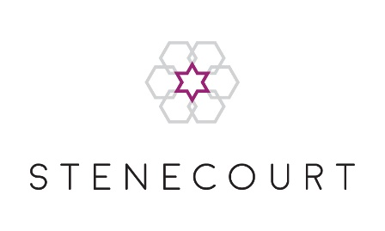

# Burial Board Membership Application Form

I wish to apply for membership of the Burial Board of the Manchester Great, New and Central Synagogue (Stenecourt).

Full Name (including title):

Address:

Telephone Number:                                                    Mobile Number:

Email Address:

Date of Birth:                                                   Hebrew Date of Birth:

Hebrew Name:

Father’s Hebrew Name:

Mother’s Hebrew Name:

Next of Kin Name:

Next of Kin Phone Number:

Next of Kin Email Address:

Please list the names (English and Hebrew) and dates of birth (English and Hebrew) of any children under the age of 21:

I have read and accept the Privacy Policy as stated at www.stenecourt.com/privacy-policy   
This Policy will inform you as to how we look after your personal data and tell you about your privacy rights and how the law protects you.

Signed: Date: